PROJECT REPORT
PICK AND PLACE ROBOTIC VEHICLE WITH SERVILANCE CAMERA

Project report submitted in partial fulfilment of the requirements for the award of the certificate of
BACHELOR OF TECHNOLOGY
(MECHANICAL AND MECHATRONICS ENGINEERING (ADDITIVE MANUFACTURING)
By
KISHOR KAILAS BADAK
202301126710
KSHITIJ MANISH RANKHAMB
202301126705
VISHAL ULHAS PAWAR
202301126706



Academic Year 2025-26
DEPARTMENT OF MECHANICAL ENGINEERING
JAWAHARLAL NEHRU ENGINEERING COLLEGE, MGM UNIVERSITY
, CHH. SAMBHAJINAGAR
CERTIFICATE

This is to certify that the project report entitled PICK AND PLACE ROBOTIC VEHICLE WITH SERVILANCE CAMERA
That is being submitted by
KISHOR KAILAS BADAK
KSHITIJ MANISH RANKHAMB
VISHAL ULHAS PAWAR
in partial fulfilment for the award of a certificate of B.TECH IN MECHANICAL AND MECHATRONICS to the, JAWAHARLAL NEHRU ENGINEERING COLLEGE is a record of bona fide work carried out by him under our guidance and supervision.

Guide Head of Department Principal
Prof. S. B. Salvi (Dr. M. S. Kadam) (Dr. V. B. Musande)
Prof. Nagargoje

Academic Year 2025-26
DEPARTMENT OF MECHANICAL ENGINEERING
JAWAHARLAL NEHRU ENGINEERING COLLEGE, MGM UNIVERSITY
, CHH. SAMBHAJINAGAR

ACKNOWLEDGEMENT

I sincerely express my gratitude to our respected principal, dr. V. B. Musande, for providing the facilities and support necessary for the successful completion of this work. I am thankful to our head of department, dr. M. S. Kadam, for his valuable guidance and encouragement.
I also extend my deep gratitude to my guide, prof. S. B. Salvi and prof. Nagargoj, for his constant guidance, support, and motivation. I am grateful to all the faculty members and staff of the department for their cooperation. I also thank my friends and classmates for their help and support, and finally, i express my heartfelt gratitude to my family for their continuous encouragement and inspiration.

Academic Year 2025-26
DEPARTMENT OF MECHANICAL ENGINEERING
JAWAHARLAL NEHRU ENGINEERING COLLEGE, MGM UNIVERSITY

ABSTRACT
In modern automation, the need for efficient and precise handling systems has led to the development of robotic pick and place mechanisms. This project presents the design and implementation of an IoT-enabled pick and place robotic arm using a NodeMCU ESP8266 microcontroller and the Blynk IoT platform. The system automates the process of detecting, picking, and placing objects from one location to another, thereby reducing human effort and improving operational efficiency. Key components include DC motors, L293D motor drivers, a robotic arm with gripper assembly, and a wireless camera for remote monitoring. The robot’s movement and operations are controlled through the Blynk mobile application, providing real-time control and feedback via the internet. The design integrates both mechanical and electronic elements, supported by Arduino IDE programming. Experimental testing demonstrated reliable performance and precise object handling. This IoT-based robotic system has potential applications in manufacturing, packaging, assembly lines, and inspection processes, contributing toward the advancement of smart automation in Industry 4.0.

INDEX
Sr. No. Content Page No.

1. INTRODUCTION 1
1.1 Introduction 1
1.2 Objective 1
- LITERATURE SURVEY 2
2.1 Literature survey 2

3. PARTS LIST AND COST 3
3.1 Parts list and cost 3
3.2 Block diagram 4
3.3 Technical Specification 5
3.3.1 Power Supply 5
3.3.2 Node MCU ESP8266 6
3.3.3 Motor Driver 10
3.3.4 DC Motor 12
3.3.5 L- Clamp 15
3.3.6 Wheels 16
3.3.7 360 Degree Rotating Wheels 17
3.3.8 Lithium-ION Battery 18
3.3.9 Robotic Arm 19
3.3.10 Camera 20
- DESIGN AND IMPLEMENTATION 21
  - Design 21
- HARDWARE DESIGN 25
  - Circuit diagram 25

6. SOFTWARE DESIGN 26
6.1 Arduino IDE 26
6.2 IoT Blynk Software ²⁸
6.3 Programming ³¹
^{7.} IMPLEMENTATION ³⁵

8. TESTING AND TECHNICAL CHALLENGES 36 9. CONCLUSION 37
9.1 Conclusion 37
9.2 Applications 38
REFERENCES 39

List of Figures
Sr. No. Name of Figures Page No.
3.1 Block diagram 4
3.2 Block diagram of power supply 5
3.3 Circuit Diagram of Power Supply 5
3.4 Node MCU 8266 pinout 7
3.5 Node MCU 8266 8
3.6 L293DPin Configuration 10
3.7 L293D Circuit diagram 11
3.8 Constructional Parts of DC Motor 12
3.9 DC Motor 13
3.10 Fleming's left hand 14
3.11 L-Clamp 15
3.12 Wheel 16
3.13 360 degree rotary wheels 17
3.14 Battery 18
3.15 Robotic Arm 19
3.16 Camera 20
4.1 Design 24
5.1 Circuit diagram 25
6.1 Arduino window 27
6.2 Blynk app 28
6.3 Blynk page 29
6.4 Create template 29
6.5 Home page 30
6.6 Metadata 30

1. INTRODUCTION

1.1 Introduction
In this highly developing society time and man power are critical constrains for completion of task in large scales. The automation is playing important role to save human efforts in most of the regular and frequently carried works. One of the major and most commonly performed works is picking and placing of jobs from source to destination. The pick and place robot is a microcontroller based mechatronic system that detects the object, picks that object from source location and places at desired location. The main exploration in this project is about robotics project including a description of the recently programmed behaviours []. The reports begin with an overview of the robot integrated system. It then continues with a description of the aspects of the robot; including robotic arm mechanisms their motor and servo actuators. This complete system allows the robot wander about its environment and to interact with certain objects that it encounters. Typically mounted on a stable stand, pick and place robots are positioned to reach different areas to perform work. They use advanced vision systems to identify, grasp and move objects from one place to another. With a variety of design options available, pick and place robots can be configured with various end-of-arm tooling options for use in different applications, such as assembly, packaging or bin picking. For example, pick and place robot systems may be used to pick up items for an order and place them in a box for packaging, or they may be used to pick up parts needed for assembly and move them to the next location. Pick and place robots are often used in manufacturing but are also used in applications such as packaging, bin picking and inspection.

1.2 Objective
Pick and place automation speeds up the process of picking up parts or items and placing them in other locations. Automating this process helps to increase production rates. Pick and place robots handle repetitive tasks while freeing up human workers to focus on more complex work.

2. LITERATURE SURVEY

2.1 Literature survey

2.1.1 Pick & Place Robot using IOT
Robot is a system that contains sensors, control systems, manipulators, power supplies and software all working together to perform a task. Designing, building, programming and testing a robot is a combination of physics, mechanical engineering, electrical engineering, structural engineering, mathematics and computing. In some cases biology, medicine, chemistry might also be involved. A study of robotics means that students are actively engaged with all of these disciplines in a deeply problem-posing problem-solving environment. A complete solution of a robot control solution is presented in this project. The robot was fully controlled by the MOBILE PHONE or PC and the commands from the MOBILE PHONE or PC via internet were received by the microcontroller. The wireless video camera, which was embedded on the robot capture the video and it was transmitted and the image, was viewed over the windows. The robot can be used in military applications.

2.1.2 Implementation of Pick and Place Robotic Arm Using Speech Processing and IoT
The pick and place robot is one of the technologies in manufacturing industry and designed to perform pick and place functions. The system is very important to eliminate human errors and to get more precise work. The rotation of this robot is 360 degree. Speech processing is the study of speech signals and the processing methods of signals. The model is trained using open-source high-level neural networks API i.e., Google assistance. The Internet of Things (IoT) means learning and interacting with millions of things including services, sensors, actuators, and many other objects on the Internet. This project enhances on how far IoT can connect devices on different platforms. The proposed system connects and controls most of the IoT devices connected to it using Voice.

3. PARTS LIST AND COST

3.1 Parts list and cost

Sr. No. | Component Name | Qty. | Rate
1. | ESP8266 | 1 | 350
2. | Diode 1N4007 | 5 | 10
3. | Capacitor | 1 | 7
4. | LM7805 | 1 | 15
5. | Resistor | 1 | 2
6. | Led | 1 | 2
7. | Battery | 1 | 600
8. | DC Motor | 2 | 400
9. | Motor drive | 2 | 600
10. | Wheels | 2 | 50
11. | Robotic arm | 1 | 3200
12. | L-clamp | 2 | 30
13. | Dummy shaft | 2 | 30
14. | Soldering gun with metal | 1 | 500
15. | Wires | 1 | 30
16. | Striper | 1 | 120
17. | Cutter | 1 | 120

3.
2

Block diagram

BLYNK APP

Fig.3.1: Block diagram

BATTERY

POWER
SUPPLY

MOTOR DRIVER
-
1

MOTOR
-
1

MOTOR
-
2

NODE MCU
ESP8266

CAMERA

MOTOR DRIVER
-
2

MOTOR
-
3

MOTOR
-
4

3.3 Technical Specification

3.3.1 Power Supply
The power supply circuits built using filters, rectifiers, and then voltage regulators. Starting with an AC voltage, a steady dc voltage is obtained by rectifying the ac voltage, then filtering to a dc level, and finally, regulating to obtain a desired fixed dc voltage. The regulation is usually obtained from an IC voltage regulator unit, which takes a dc voltage and provides a somewhat lower dc voltage, which remains the same even if the input dc voltage varies, or the output load connected to the dc voltage changes.
A rectifier is used for the converting a.c. supply into d.c supply. A bridge IC is used for that purpose. To get the power supply for the circuit , 230V ac main voltage is step down by the step down transformer X1 which is rectified by the bridge rectifier into the DC voltage and is filtered out by the capacitor C1 of (100uF, 25V) rating. The filtered output fed to the input pin i.e. pin no.1 of the regulator IC 7805 and 7812. This gives the fixed 5V and 12V DC power Supply respectively. The block diagram of power supply is shown in fig below.


Fig.3.
2
Block diagram of power supply
:

TRANSFORM
ER

STEP DOWN

BRIDGE

RECTIFIER

FILTER

VOLTAGE
REGULATOR

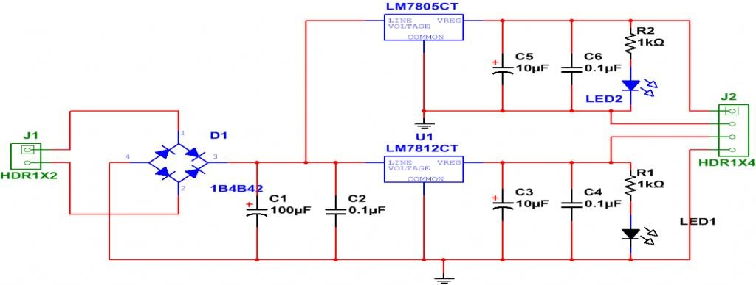

Fig.3.3: Circuit Diagram of Power Supply

3.3.2 Node MCU ESP8266
The NodeMCU ESP8266 development board is equipped with the ESP-12E module, which contains the ESP8266 chip featuring a 32-bit LX106 RISC microprocessor. This microprocessor supports real-time operating systems (RTOS) and operates at an adjustable clock frequency of 80MHz to 160MHz. The NodeMCU board has 128KB of RAM and 4MB of Flash memory for data storage and program execution. Its high processing power, built-in WiFi/Bluetooth capabilities, and Deep Sleep Operating features make it an ideal choice for IoT projects.
Programming the NodeMCU board with the Arduino IDE is straightforward and can be accomplished in just 5-10 minutes. You can refer to a Getting Started Tutorial for NodeMCU to configure your Arduino IDE for NodeMCU development. The NodeMCU board can be powered using a Micro USB jack or the VIN pin, which allows for external power supply. It supports UART, SPI, and I2C interfaces, providing flexibility for different communication requirements.
The ESP8266 module is a user-friendly and cost-effective device that enables internet connectivity in your projects. It can function as both an access point (creating a hotspot) and a station (connecting to Wi-Fi), allowing for easy data retrieval and uploading to the internet. With support for APIs, the module can fetch data from the internet, making your project smarter by accessing a wide range of online information. Furthermore, the module can be programmed using the Arduino IDE, enhancing its usability for developers. It's worth noting that this version of the module has only 2 GPIO pins (though it can be hacked to use up to 4), so using it alongside another microcontroller like Arduino is common practice. Alternatively, you can explore standalone ESP-12 or ESP-32 versions if more GPIO pins are needed. It's important to mention that the ESP8266 module operates at 3.3V only, and voltages higher than 3.7V can damage the module. Therefore, caution must be exercised in circuit designs. It is recommended to use an FTDI board that supports 3.3V programming. If you don't have one, you can use an Arduino board temporarily. One common issue faced with the ESP01 module is the power supply. The module consumes significant power during programming, and it can be powered using a 3.3V pin on Arduino or by using a voltage divider. It is essential to implement a small voltage regulator for a stable 3.3V supply capable of providing at least 500mA.
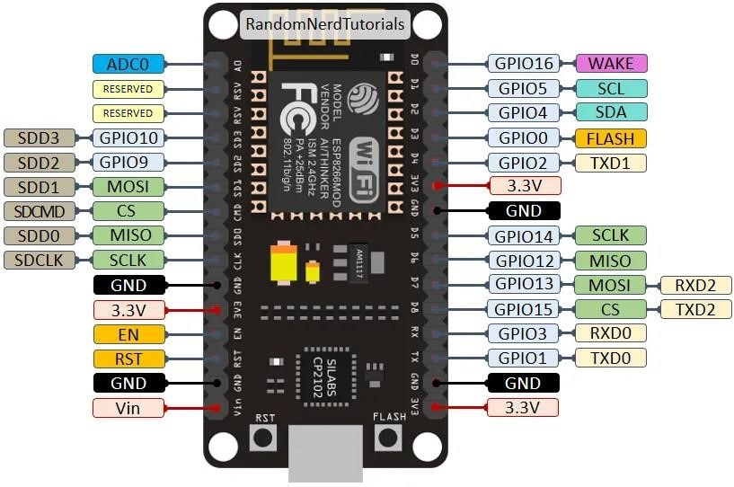

Fig.3.4: Node MCU 8266 pinout
The Arduino IDE is indeed one of the most commonly used methods for programming ESP modules. It provides a user-friendly interface and simplifies the development process. However, there are other methods and Integrated Development Environments (IDEs) available for programming ESP modules as well. It is crucial to note that the ESP8266 module operates with a voltage of 3.3V only. Applying a voltage higher than 3.7V can cause damage to the module, so it's important to exercise caution when designing circuits. The recommended approach to program an ESP-01 module is by using an FTDI board that supports 3.3V programming. If you don't have an FTDI board, it is advisable to purchase one. As an alternative, you can temporarily use an Arduino board for programming.
One common issue encountered with the ESP-01 module is related to powering it up. During programming, the module requires a significant amount of power. To address this, you can power the module using the 3.3V pin on the Arduino board or by employing a potential divider circuit. It is essential to create a small voltage regulator that can supply a stable 3.3V output with a minimum current rating of 500mA. One recommended voltage regulator for this purpose is the LM317, which can handle the job effectively.
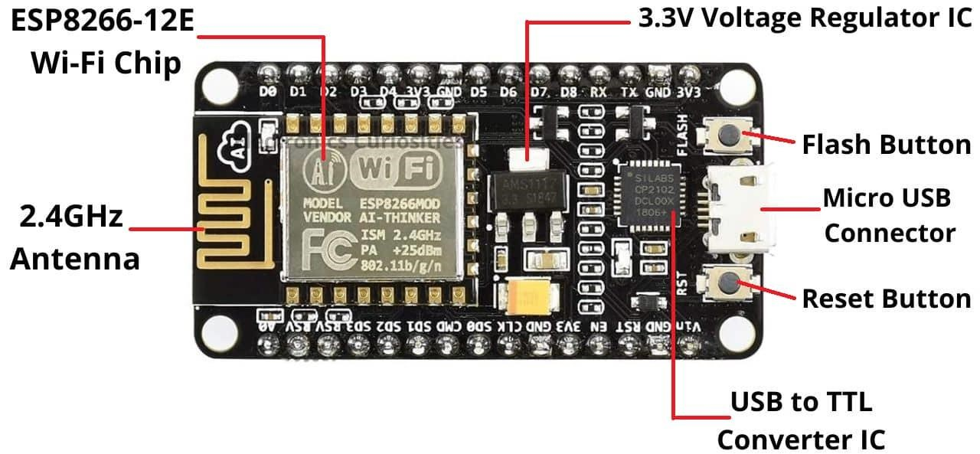

Fig.3.5: Node MCU 8266
The ESP8266 chip gained recognition among Western makers in August 2014 with the introduction of the ESP-01 module, manufactured by a third-party company called Ai-Thinker. This compact module enabled microcontrollers to connect to Wi-Fi networks and establish simple TCP/IP connections using Hayes-style commands. However, during the initial stages, there was limited documentation available in English regarding the chip and its supported commands. Despite the initial language barrier, the module gained popularity due to its extremely low price and minimal external component requirements. This attracted numerous hackers and enthusiasts to explore the module, the underlying chip, and its software. Many individuals undertook the task of translating the Chinese documentation to make it more accessible to the English-speaking community. The ESP8285, a variation of the ESP8266 chip, was later introduced. It incorporated 1 MiB of built-in flash memory, allowing the creation of single-chip devices capable of connecting to Wi-Fi networks. Subsequently, the ESP32 family of devices was introduced, which succeeded the ESP8266 and included the pin-compatible ESP32-C3 variant.
Features:
- 17 GPIO pins
- I²C (software implementation)
- I²S interfaces with DMA (sharing pins with GPIO)
- UART on dedicated pins, plus a transmit-only UART can be enabled on GPIO2
- 10-bit ADC (successive approximation ADC)
- Can be used as Station or Access Point or both combined
- Supports Deep sleep (<10uA)
- Supports serial communication hence compatible with many development platform like Arduino
- Operating Voltage: 3.3V
- Input Voltage: 7-12V
- Digital I/O Pins (DIO): 16
- Analog Input Pins (ADC): 1
- UARTs: 1
- SPIs: 1
- I2Cs: 1
- Flash Memory: 4 MB
- SRAM: 64 KB

3.3.3 Motor Driver
L293D is a typical Motor driver or Motor Driver IC which allows DC motor to drive on either direction. L293D is a 16-pin IC which can control a set of two DC motors simultaneously in any direction. It means that you can control two DC motor with a single L293D IC. Dual H-bridge Motor Driver integrated circuit (IC). The l293d can drive small and quiet big motors as well, check the Voltage Specification at the end of this page for more info. It works on the concept of H-bridge. H-bridge is a circuit which allows the voltage to be flown in either direction. As you know voltage need to change its direction for being able to rotate the motor in clockwise or anticlockwise direction, hence H-bridge IC are ideal for driving a DC motor.
In a single L293D chip there are two h-Bridge circuit inside the IC which can rotate two dc motor independently. Due its size it is very much used in robotic application for controlling DC motors. Given below is the pin diagram of a L293D motor controller.
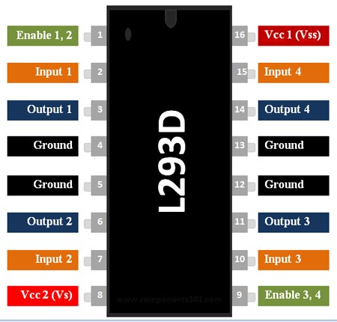
Fig.3.6: L293DPin Configuration
There are two Enable pins on l293d. Pin 1 and pin 9, for being able to drive the motor, the pin 1 and 9 need to be high. For driving the motor with left H-bridge you need to enable pin 1 to high. And for right H-Bridge you need to make the pin 9 to high. If anyone of the either pin1 or pin9 goes low then the motor in the corresponding section will suspend working. Its like a switch.
The L293D is a popular 16-Pin Motor Driver IC. As the name suggests it is mainly used to drive motors. A single L293D IC is capable of running two DC motors at the same time; also the direction of these two motors can be controlled independently. Using this L293D motor driver IC is very simple. The IC works on the principle of Half H-Bridge, let us not go too deep into what H-Bridge means, but for now just know that H bridge is a setup which is used to run motors both in clock wise and anti-clockwise direction. As said earlier this IC is capable of running two motors at the any direction at the same time, the circuit to achieve the same is shown below.
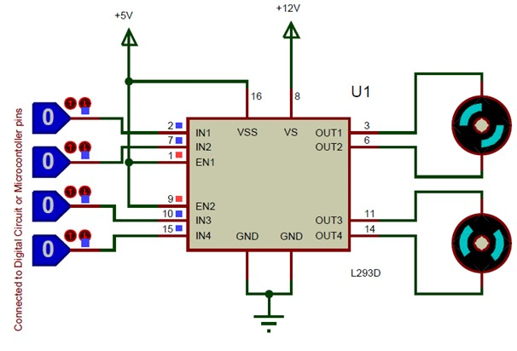

Fig.3.7: L293D Circuit diagram
All the Ground pins should be grounded. There are two power pins for this IC, one is the Vss(Vcc1) which provides the voltage for the IC to work, this must be connected to +5V. The other is Vs(Vcc2) which provides voltage for the motors to run, based on the specification of your motor you can connect this pin to anywhere between 4.5V to 36V, here I have connected to +12V.The Enable pins (Enable 1,2 and Enable 3,4) are used to Enable Input pins for Motor 1 and Motor 2 respectively. Since in most cases we will be using both the motors both the pins are held high by default by connecting to +5V supply. The input pins Input 1,2 are used to control the motor 1 and Input pins 3,4 are used to control the Motor 2. The input pins are connected to the any Digital circuit or microcontroller to control the speed and direction of the motor. You can toggle the input pins based on the following table to control your motor.

3.3.4 DC Motor
DC motors are configured in many types and sizes, including brush less, servo, and gear motor types. A motor consists of a rotor and a permanent magnetic field stator. The magnetic field is maintained using either permanent magnets or electromagnetic windings. DC motors are most commonly used in variable speed and torque.
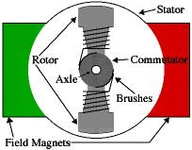

Fig.3.8: Constructional Parts of DC Motor
Motion and controls cover a wide range of components that in some way are used to generate and/or control motion. Areas within this category include bearings and bushings, clutches and brakes, controls and drives, drive components, encoders and resolves, Integrated motion control, limit switches, linear actuators, linear and rotary motion components, linear position sensing, motors (both AC and DC motors), orientation position sensing, pneumatics and pneumatic components, positioning stages, slides and guides, power transmission (mechanical), seals, slip rings, solenoids, springs.
Motors are the devices that provide the actual speed and torque in a drive system. This family includes AC motor types (single and multiphase motors, universal, servo motors, induction, synchronous, and gear motor) and DC motors (brush less, servo motor, and gear motor) as well as linear, stepper and air motors, and motor contactors and starters. In any electric motor, operation is based on simple electromagnetism. A currentcarrying conductor generates a magnetic field; when this is then placed in an external magnetic field, it will experience a force proportional to the current in the conductor, and to the strength of the external magnetic field. As you are well aware of from playing with magnets as a kid pposite (North and South) polarities attract, while like polarities (North and North, South and South) repel. The internal configuration of a DC motor is designed to harness the magnetic interaction between a current-carrying conductor and an external magnetic field to generate rotational motion. Let's start by looking at a simple 2-pole DC electric motor (here red represents a magnet or winding with a "North" polarization, while green represents a magnet or winding with a "South" polarization).
Every DC motor has six basic parts -- axle, rotor (a.k.a., armature), stator, commutator, field magnet(s), and brushes. In most common DC motors (and all that Beamers will see), the external magnetic field is produced by high-strength permanent magnets¹. The stator is the stationary part of the motor -- this includes the motor casing, as well as two or more permanent magnet pole pieces. The rotor (together with the axle and attached commutator) rotates with respect to the stator. The rotor consists of windings (generally on a core), the windings being electrically connected to the commutator. The above diagram shows a common motor layout -- with the rotor inside the stator (field) magnets.
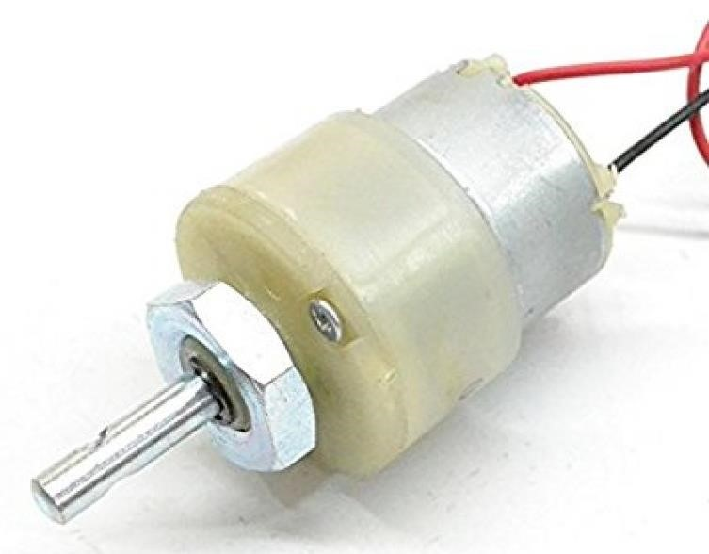

Fig.3.9: DC Motor
The geometry of the brushes, commutator contacts, and rotor windings are such that when power is applied, the polarities of the energized winding and the stator magnet(s) are misaligned, and the rotor will rotate until it is almost aligned with the stator's field magnets. As the rotor reaches alignment, the brushes move to the next commutator contacts, and energize the next winding. Given our example two-pole motor, the rotation reverses the direction of current through the rotor winding, leading to a "flip" of the rotor's magnetic field, and driving it to continue rotating.
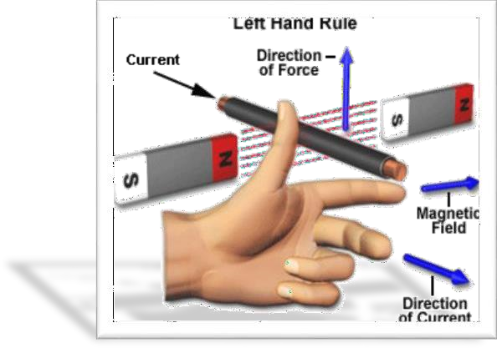

Fig.3.10: Fleming's left hand
As soon as we supply direct current in the armature, a mechanical force acts on it due to the electromagnetic effect of the magnet. Now to go into the details of the operating principle of DC motor it's important that we have a clear understanding of Fleming’s left-hand rule to determine the direction of the force acting on the armature conductors of DC motor.
A motor is an electrical machine which converts electrical energy into mechanical energy. The principle of working of a DC motor is that "whenever a current carrying conductor is placed in a magnetic field, it experiences a mechanical force". The direction of this force is given by Fleming's left hand rule and its magnitude is given by F = BIL. Where, B = magnetic flux density, I = current and L = length of the conductor within the magnetic field.
Fleming's left hand rule: If we stretch the first finger, second finger and thumb of our left hand to be perpendicular to each other AND direction of magnetic field is represented by the first finger, direction of the current is represented by second finger then the thumb represents the direction of the force experienced by the current carrying conductor.

3.3.5 L- Clamp
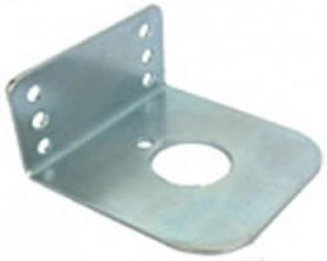

Fig.3.11: L-Clamp
Principles of clamping devices are used to hold the workpiece in the correct relative position in the jig or fixture. It should ensure that the workpiece is not displaced under the action of cutting forces. For efficient operation, firm clamping of the workpiece is a must. An inadequate clamping may always prove dangerous. Clamping devices are designed for minimum operating and handling time. (i) The applied clamping pressures against the workpiece must counteract the tool forces.
(ii)The clamping force should be kept minimum. It must only hold the workpiece and should never be great enough so as to damage the workpiece.
- The clamping pressure should be exerted on the solid supporting part of the workpiece to prevent distortion.
- Clamping should be simple, quick operating and foolproof.
- The clamping pressure should be directed parallel to cutting operation. i.e., it should not be directed towards the cutting

3.3.6 Wheels
One of the most basic of mechanical devices, the wheel has been around in one form or another since about 6500 BC. It’s likely that we will continue to use wheels for many millennia to come. Robots, of course, have not been around for anywhere near that time, even fictional robots. And some robots don’t even use wheels, tractor treads or legs are other methods of locomotion you could use. But wheels are simple to use and are the basis of many robot designs. The size of the wheel is an obvious parameter to consider, and it can affect the design of many elements of your robot. The chassis design, the motor speed ratings and the motor controller programming are all affected by the size of the wheels.
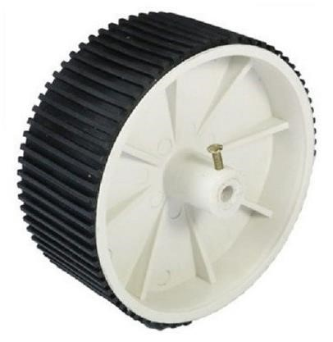

Fig.3.12: Wheel
The width of the wheel can affect the steering, especially when using skid steering. Skid steering is when you steer the robot by altering the speed of its wheels, DB1 uses this technique as do most hobbyist robots due to its simplicity. The wider the wheel the less accurate the skid steering will be. Other forms of steering, such as rack-and-pinion, do not suffer from this limitation.
A thicker or patterned tread can be useful for an outdoor design, especially one that is meant to be used “off road”.
Specification Motor:
- Shaft Diameter – 6 mm
- Wheel Diameter – 70 mm
- Wheel Width – 20 mm
- Weight: 33gm/Wheel

3.3.7 360 Degree Rotating Wheels
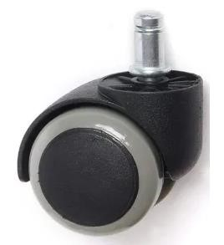

Fig.3.13: 360 degree rotary wheels
This project is about 360-degree rotating vehicle. This vehicle moves in all directions and this design provides better comfort and also saves the time, most of the people uses this vehicle to carry goods, emergency patients etc. The normal wheel vehicles face lot of problems like parking, U turn and much more which consumes more time. So, we have designed a 360degree wheel rotating vehicle to reduce and eliminate problems in the industry as well as common life of people. The vehicle can take a turn without moving the vehicle. No extra space is required to turn the vehicle. In this system, each of the 4 wheels has given drive with DC motors, so it can rotate 360 degree. 360-degree rotating wheel is controlled by RF remote. Consequently, we can utilize this 360-degree rotating vehicle from various perspectives like to transport things overwhelming bags and furthermore in vehicles, which will help in decreasing rush hour gridlock and spare time.

3.3.8 Lithium-ION Battery
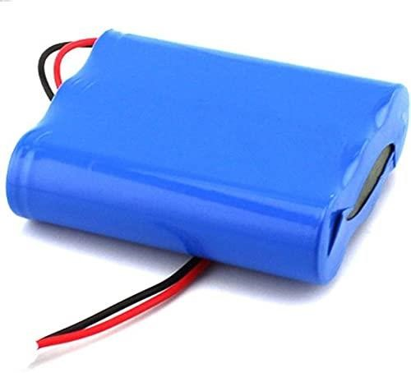

Fig.3.14: Battery
- Model : 11.1V 2200MAH
- Product Dimensions :7.62 x 3.81 x 5.08 cm
- Batteries: 3 Lithium Ion batteries required.
- Item model number : 11.1V 2200MAH
- Compatible Devices : Controller
- Mounting Hardware: LITHIUN
- Voltage : 11.1 Volts
- Battery Capacity : 2200 Milliamp Hours • Battery cell composition: Lithium Ion

3.3.9 Robotic Arm
A robotic Arm module is divided into two major working modules, one is the gripper module and other is gearbox module. These both modules are made up from laser cut metal and acrylic which assure their durability in various robotics applications. The gear box module consists of a worm gear assembly which increases torque so that the end effector can pick up more loads. The gripper module is specially designed for pick and place objects. These modules can be combined together to form a pick and place assembly with an ability to lift heavy loads. This assembly can be used in a robotic system to automate existing pick and place system.
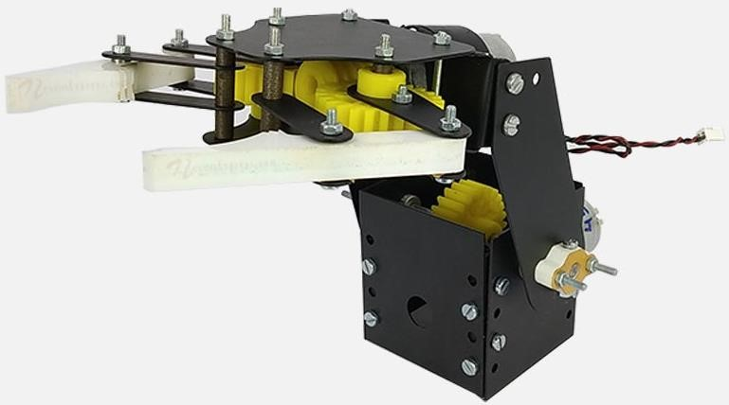

Fig.3.15: Robotic Arm
- Body Material: Metal
- Gripper Material: Plastic
- Color: Black & White
- Size: 220 x 140 x 200mm
- Weight: 2000 Grams
- 1 x Robotic Arm Gripper and Gear box Set
- 2 x 12V DC Geared Motors

3.3.10 Camera
The V380 Pro camera is a smart IP surveillance device that works with the V380 Pro mobile application to provide remote monitoring, recording, and security management. It allows users to view live video streams from anywhere, replay recorded footage, and receive instant motion detection alerts directly on their smartphones. Many models support advanced features such as pan, tilt, and rotation control, as well as two-way audio that enables real-time communication through the built-in microphone and speaker. For nighttime security, infrared night vision ensures clear footage even in low-light environments, while some outdoor models also offer waterproofing for weather resistance. Storage options include both local SD card recording and cloud storage, although extended cloud storage requires a subscription. The system also supports device sharing, allowing multiple users to access the same camera feed. Overall, the V380 Pro offers a cost-effective and versatile security solution, though performance and features may vary depending on the specific camera model, and some users have reported occasional playback or connectivity issues.
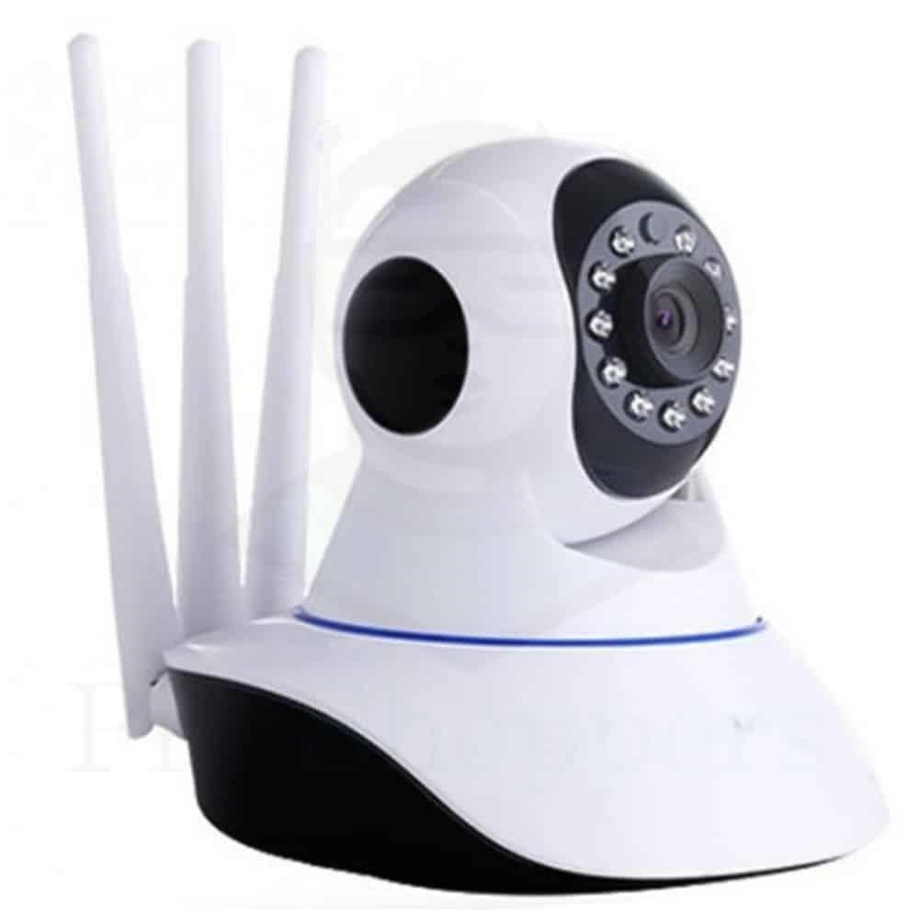
Fig.3.16: Camera

4. DESIGN AND IMPLEMENTATION

4.1 Design
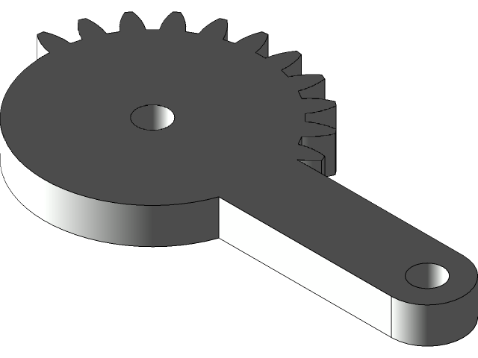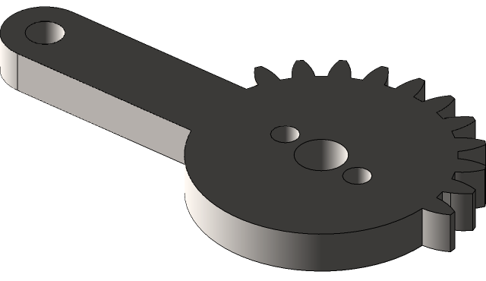

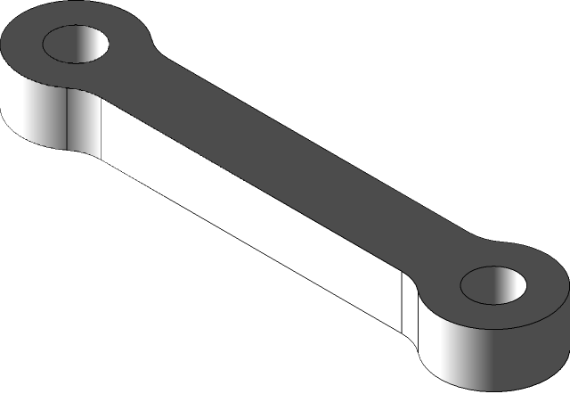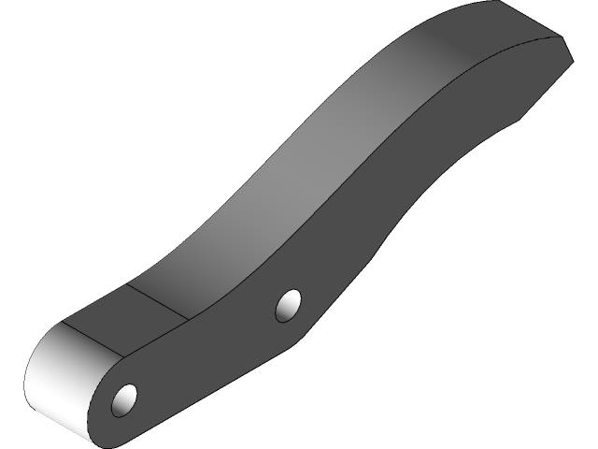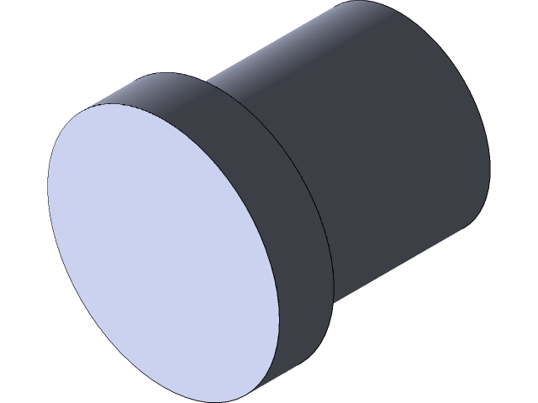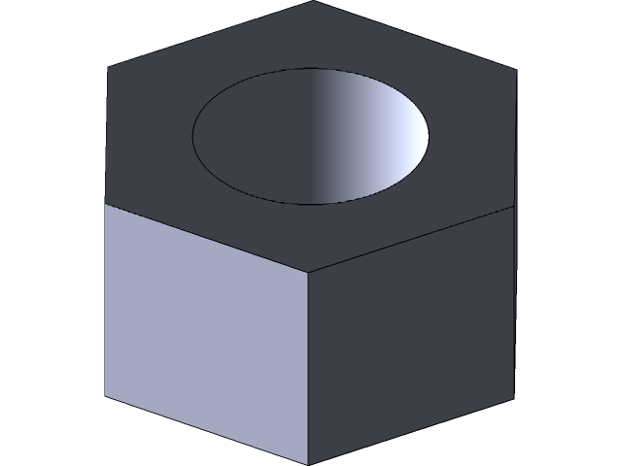

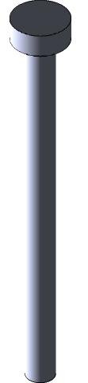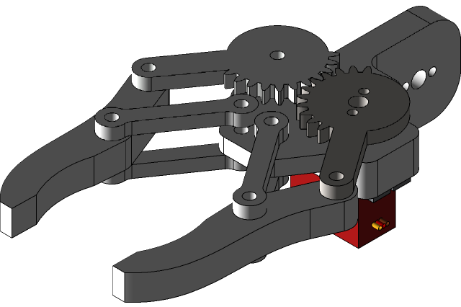
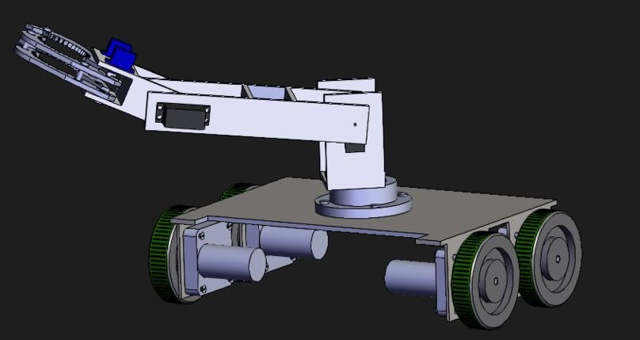
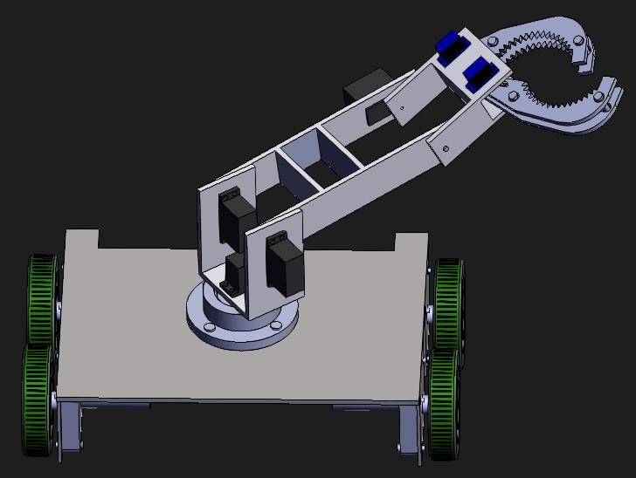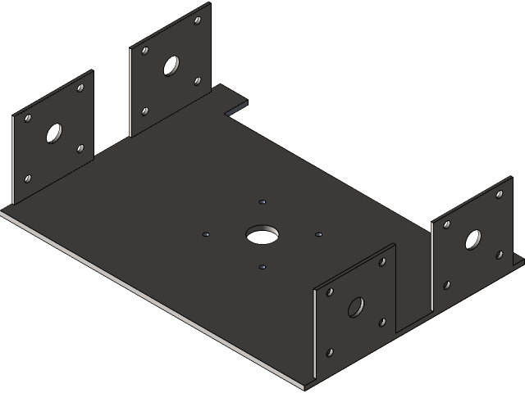

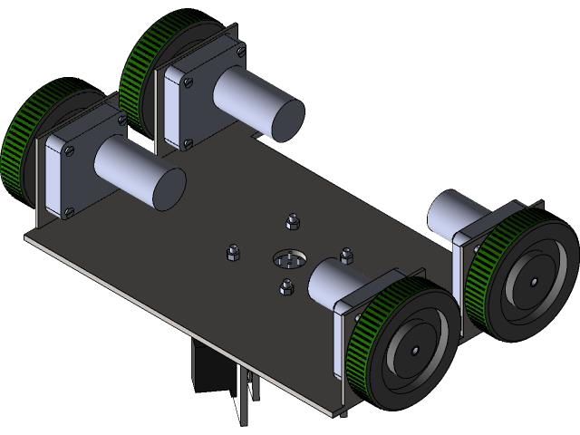

Fig.4.1: Design

5. HARDWARE DESIGN

5.1 Circuit diagram
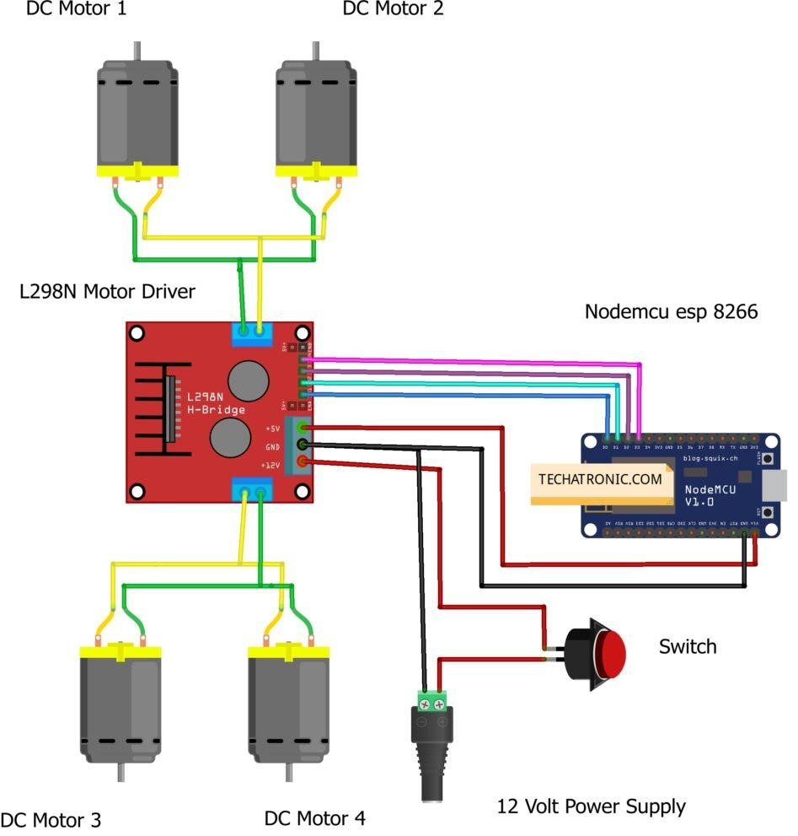
Fig.5.1: Circuit diagram

6. SOFTWARE DESIGN

6.1 Arduino IDE
The Arduino Integrated Development Environment (IDE) is a crossplatform application (for Windows, macOS, Linux) that is written in functions from C and C++. It is used to write and upload programs to Arduino compatible boards, but also, with the help of third-party cores, other vendor development boards.
The source code for the IDE is released under the GNU General Public License, version 2. The Arduino IDE supports the languages C and C++ using special rules of code structuring. The Arduino IDE supplies a software library from the Wiring project, which provides many common input and output procedures. User-written code only requires two basic functions, for starting the sketch and the main program loop, that are compiled and linked with a program stub main() into an executable cyclic executive program with the GNU toolchain, also included with the IDE distribution. The Arduino IDE employs the program avr dude to convert the executable code into a text file in hexadecimal encoding that is loaded into the Arduino board by a loader program in the board's firmware. By default, avrdude is used as the uploading tool to flash the user code onto official Arduino boards.
Arduino IDE is a derivative of the Processing IDE, however as of version 2.0, the Processing IDE will be replaced with the Visual Studio Code-based Eclipse Theia IDE framework. With the rising popularity of Arduino as a software platform, other vendors started to implement custom open source compilers and tools (cores) that can build and upload sketches to other microcontrollers that are not supported by Arduino's official line of microcontrollers. Arduino IDE is an open source software that is mainly used for writing and compiling the code into the Arduino Module.
It is official Arduino software, making code compilation too easy that even a common person with no prior technical knowledge can get their feet wet with the learning process. It is easily available for operating systems like MAC, Windows, Linux and runs on the Java Platform that comes with inbuilt functions and commands that play a vital role for debugging, editing and compiling the code in the environment.

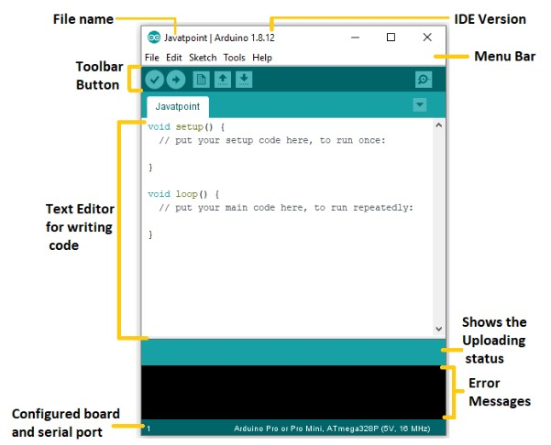

Fig.6.1: Arduino window
Each of them contains a microcontroller on the board that is actually programmed and accepts the information in the form of code. The main code, also known as a sketch, created on the IDE platform will ultimately generate a Hex File which is then transferred and uploaded in the controller on the board. The IDE environment mainly contains two basic parts: Editor and Compiler where former is used for writing the required code and later is used for compiling and uploading the code into the given Arduino Module.
This environment supports both C and C++ languages.

6.2 IoT Blynk Software
Blynk is the most popular IoT platform for connecting devices to the cloud, designing apps to remotely control and monitor them, and managing thousands of deployed products. It's a PaaS (Platform-as-a-Service) that helps individuals and organizations to seamlessly progress from a prototype of a connected product to its commercial launch. With over 400 hardware models support, customers can connect any device to the Internet and use suit of software products to launch commercial projects. Everything you need to build and manage connected hardware: device provisioning, sensor data visualization, remote control with mobile and web applications, Over-The-Air firmware updates, secure cloud, data analytics, user and access management, alerts, automations and much more. Blynk platform powers low-batch manufacturers of smart home products, complex HVAC systems, agricultural equipment, and everyone in between. These companies build branded apps with no code and get the full back- end IoT infrastructure through one subscription.
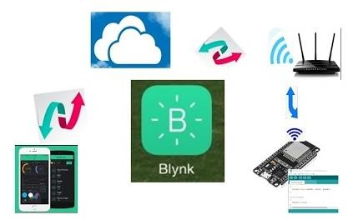

Fig.6.2: Blynk app

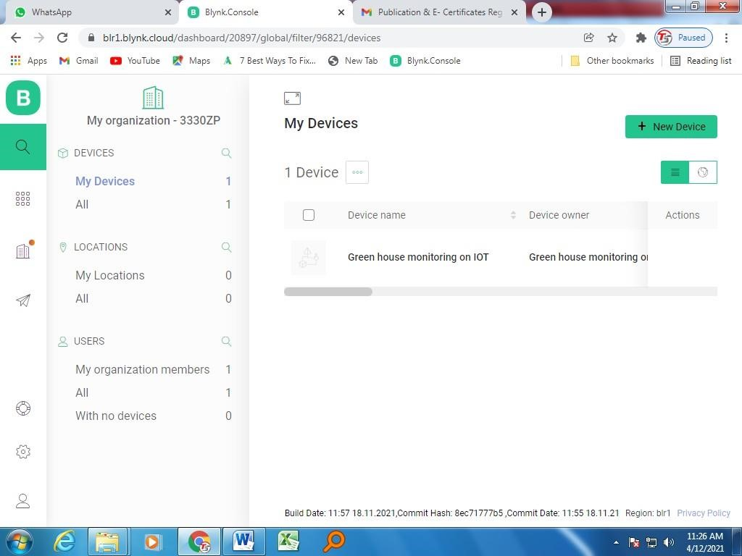

Fig.6.3: Blynk page
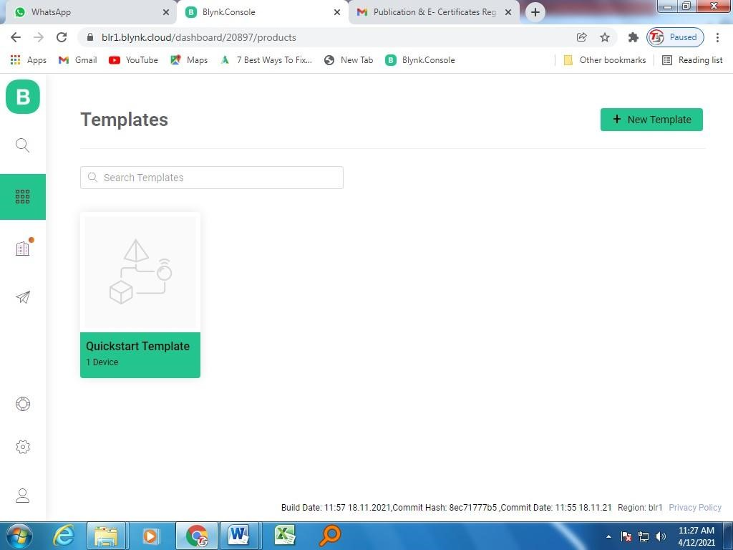

Fig.6.4: Create template
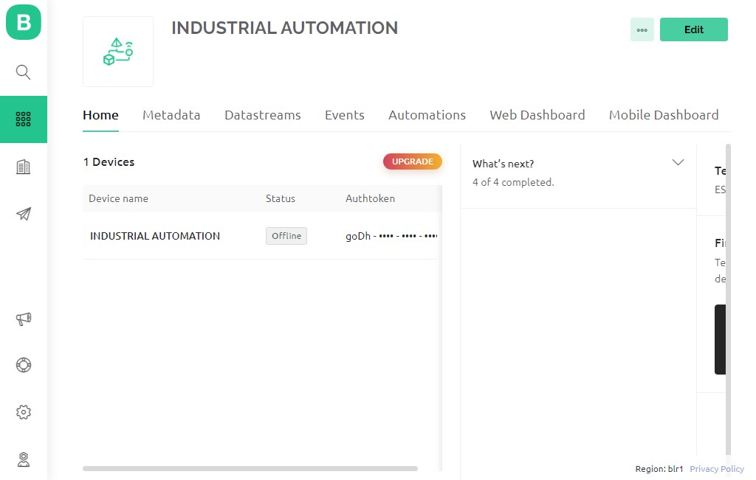 Fig.4.5: Home page

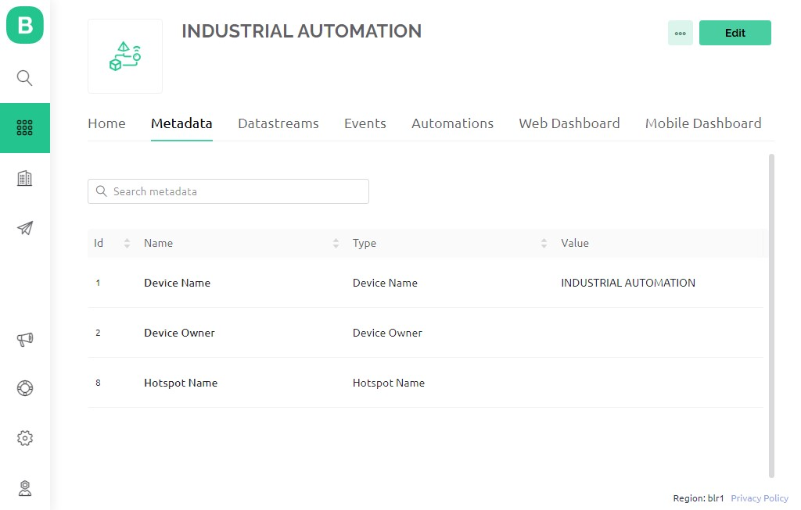

Fig.4.6: Metadata

6.3 Programming
int fronttrigPin = 7; int frontechoPin = 6; int righttrigPin = 9; int rightechoPin = 8; int lefttrigPin = 3; int leftechoPin = 5; int IRsensorC = A0; int SensorvalueC = 0; int E1 = 10; int M1 = 11; int E2 = 12; int M2 = 13; int leftdistance=0,rightdistance=0,frontdistance=0;
#include <Servo.h>
Servo gripper;
Servo arm; Servo arm2; char incoming_byte = 0;
int value = 0; int pos = 0;
#define MAX_DISTANCE = 200;
long duration, distance;

void setup() { pinMode(fronttrigPin, OUTPUT); pinMode(frontechoPin, INPUT); pinMode(righttrigPin, OUTPUT); pinMode(rightechoPin, INPUT); pinMode(lefttrigPin, OUTPUT); pinMode(leftechoPin, INPUT);
pinMode(M1, OUTPUT); pinMode (M2, OUTPUT);
Serial.begin(9600); gripper.attach(A3); arm.attach(A4); arm2.attach(A5); pinMode(IRsensorC, INPUT); } void loop() { duration = pulseIn(frontechoPin, HIGH); duration = pulseIn(leftechoPin, HIGH); duration = pulseIn(rightechoPin, HIGH); distance = duration / 58.2; delay(10);
SensorvalueC = analogRead (IRsensorC); if (SensorvalueC <= 250) // gripping the load
{ gripper.write(90); } if ((frontdistance <10 )&(leftdistance <20)&(rightdistance <20)) // pick and place part
{ digitalWrite (M1, HIGH); // turn right facing the load
analogWrite (E1,80); digitalWrite (M2, LOW); analogWrite (E2, 80); delay(500); digitalWrite (M1, HIGH); // stop to pickup load analogWrite (E1,0); digitalWrite (M2, HIGH); analogWrite (E2, 0); arm.write (50); arm2.write (50); delay(10000); digitalWrite (M1, HIGH); //turn right after picking up load analogWrite (E1,80); digitalWrite (M2, LOW); analogWrite (E2, 80); arm.write (0); arm2.write (0); delay(500); digitalWrite (M1, HIGH); // go straight analogWrite (E1,80); digitalWrite (M2, HIGH); analogWrite (E2, 80); delay (1000); digitalWrite (M1, LOW); // left turn analogWrite (E1,80);
digitalWrite (M2, HIGH); analogWrite (E2, 80); digitalWrite (M1, HIGH); // go straight to place load analogWrite (E1,80); digitalWrite (M2, HIGH); analogWrite (E2, 80); delay(10000); digitalWrite (M1, LOW); // left turn analogWrite (E1,80); digitalWrite (M2, HIGH); analogWrite (E2, 80); delay(500); digitalWrite (M1, HIGH); // go straight analogWrite (E1,80); digitalWrite (M2, HIGH); analogWrite (E2, 80); delay (1000); digitalWrite (M1, HIGH); // stop to place load analogWrite (E1,0); digitalWrite (M2, HIGH); analogWrite (E2, 0); arm.write (50); arm2.write (50); gripper.write (0);
}

7. IMPLEMENTATION
- This stage involves designing the physical structure of the robot, determining its specifications, and planning the overall system architecture. It includes selecting appropriate components such as motors, sensors, microcontrollers, and connectivity modules. The design and planning phase lays the foundation for the subsequent steps.
- Once the design is finalized, the physical construction of the robot takes place. This involves assembling the mechanical components, connecting the electronic elements, and integrating the required sensors and actuators. The robot is built according to the design specifications.
- The robot's control system is developed using programming languages and software tools. This includes coding the microcontroller or embedded system that controls the robot's movements, interprets sensor data, and operates the gripper mechanism. The control system ensures that the robot responds appropriately to input and performs the desired pick and place actions.
- IoT capabilities are incorporated into the robot by adding wireless connectivity modules, such as Wi-Fi or Bluetooth. These modules enable communication between the robot and other IoT devices or systems. Integration may involve configuring network settings, establishing communication protocols, and ensuring interoperability with IoT platforms or cloud services.
- A cloud-based application or web interface is developed to interact with the pick and place robot. This application allows users to control the robot remotely, monitor its operations, and access real-time data. The application may include features such as task scheduling, error handling, and visualization of robot status and performance.
- After the initial implementation, thorough testing is carried out to verify the functionality, accuracy, and reliability of the pick and place robot. Real-world scenarios and use cases are simulated to ensure that the robot operates as intended. Any issues or shortcomings identified during testing are addressed, and necessary refinements are made to improve the robot's performance.

8. TESTING AND TECHNICAL CHALLENGES

- Objects that need to be picked and placed may come in various shapes, sizes, and weights. Dealing with object variability poses challenges in terms of adapting gripper designs and strategies for handling different objects effectively.
- Addressing these challenges requires a combination of mechanical design, software development, robotics expertise, and extensive testing and validation processes.
- When developing a pick and place robot using the Blynk app and a programming, there are several technical challenges that you may occurred.
- The stability and reliability of the network connection between the Blynk app and the coding are critical.
- Implementing proper error handling, connection monitoring, and network redundancy mechanisms can help mitigate these challenges.

9. CONCLUSION

9.1 Conclusion
Designing and fabricating of the robotic arm has been successfully completed. The design for the manipulator has been recognized. The power is estimated based on the torque. The dc motor is selected for each load based on torque requirement. Selecting a suitable motor driver and control software for the Robotic arm is developing using C++ programming language. The experiments are conducted on the pick and place robot and the results obtained were very satisfactory. Motors with higher torque ratings can used to power the joints so as to ensure that the robotic arm can object pick and place anywhere by using IOT cloud.

9.2 Applications
- Assembly – Pick and place robots used in assembly applications grab incoming parts from one location, such as a conveyor, and place or affix the part on another piece of the item. The two joined parts are then transported to the next assembly area.
- Packaging – Pick and place robots used in the packaging process grab items from an incoming source or designated area and place the items in a packaging container.
- Bin picking – Pick and place robots used in bin picking applications grab parts or items from bins. These pick and place robots typically have advanced vision systems allowing them to distinguish color, shape and size to pick the right items even from bins containing randomly mixed items. These parts or items are then sent to another location for assembly or packaging.
- Inspection – Pick and place robots used for inspection applications are equipped with advanced vision systems to pick up objects, detect anomalies and remove defective parts or items by placing them in a designated location.

REFERENCES
- Priyambada Mishra, Riki Patel, Trushit Upadhyaya, Arpan Desai “Review of Development
Of Robotic Arm Using Arduino UNO”, International Journal on Recent Researches in Science, Engineering and Technology, ISSN: 2348-3105 Volume 5, Issue 5, May 2017.
- Puran Singh, Anil Kumar, Mahesh Vashishth “Design of Robotic Arm with Gripper and
End effector for spot welding”, Universal Journal of Mechanical Engineering 1(3); 92-97, 2013, DOI: 10.13189/ujme,2013.010303.
- Areepen Sengsalonga , Nuryono Satya Widodo “ ObjectMoving Robot Arm based on Color”, Signal and Image Processing Letters, Vol.1., No.3, November 2019, pp. 13-19 ISSN 2714-6677.
- V. K. Banga, Jasjit Kaur, R. Kumar, Y. Singh “Modeling and Simulation of Robotic Arm
Movement using Soft Computing”, International Journal of Mechanical And Mechatronics Engineering, Vol:5, No:3,2011.
- Kemal Oltun Evliyaoğlu1, Meltem Elitaş “Design and Development of a Self-
Adaptive,Reconfigurable and LowCost Robotic Arm” Department of Mechatronics Engineering, Sabanci University. Üniversite St. No:27, 34956 Tuzla/İstanbul Turkey1
- Anughna N, Ranjitha V, Tanuja G “Design and Implementation of Wireless Robotic Arm
Model using Flex and Gyro Sensor”, International Journal of Recent Technology and Engineering (IJRTE) ISSN: 2277-3878, Volume-8 Issue-5, January 2020.
- Kurt E. Clothier and Ying Shang “A Geometric Approach for Robotic Arm Kinematics with Hardware Design, Electrical Design, and Implementation” Hindawi Publishing CorporationJournal of Robotics Volume 2010, Article ID 984823, 10 pages doi:10.1155/2010/984823
- Gurudu Rishank Reddy and Venkata Krishna Prashanth Eranki “Design and Structural
Analysis of a Robotic Arm” Blekinge Institute of Technology, Karlskrona, Sweden, 2016, ISRN: BTH-AMT-EX--2016/D06—SE.
- Dr. Bindu A Thomas, Stafford Michahial, Shreeraksha.P, Vijayashri B Nagvi, Suresh M
“Industry Based Automatic Robotic Arm”, International Journal of Engineering and
Innovative Technology (IJEIT) Volume 2, Issue 11, May 2013, ISSN: 2277-3754 ISO
9001:2008 Certified
- A Hui Wei and B Yang Chen, “Robotic object recognition and grasping with a natural background”, International Journal of Advanced Robotic Systems, March-April 2020: 1– 17, DOI: 10.1177/1729881420921102.
- Yagna Jadeja, Bhavesh Pandya “Design and Development Of 5-DOF Robotic Arm
Manipulators”, INTERNATIONAL JOURNAL OF SCIENTIFIC & TECHNOLOGY
RESEARCH, Volume 8, Issue 11, November 2019, ISSN 2277- 8616.
- Timothy Karl Findling “Robotic Arm Tracing Curve Recognized by Camera”, Florida Institute of Technology, Melbourne, Florida December, 2016.
- Shamsheer Verma “Hand Gestures Remote Controlled Robotic Arm”, Advance in
Electronic and Electric Engineering. ISSN 2231-1297, Volume 3, Number 5 (2013), pp. 601-606.
- Nasr M. Ghaleb and Ayman A. Aly “Modeling and Control of 2-DOF Robot Arm”,
International Journal of Emerging Engineering Research and Technology Volume 6, Issue 11, 2018, PP 24-31 ISSN 2349-4395 (Print) & ISSN 2349-4409 (Online).
- Sudharsan, J.* & Karunamoorthy, L. “Path Planning and Co-simulation Control of 8 DOF
Anthropomorphic Robotic Arm”, Department of Mechanical Engineering, CEG Campus, Anna University, Chennai, India.
- Dishant Khosla, Manvinder Sharma, Sachin Krishan Khanna, Pratibha,Khanna, Gurpreet
Kaur “Smart Robotic Arm”, Journal of Artificial Intelligence Research & Advances,ISSN: 2395-6720 (Online),Volume 6, Issue2
- Mohammed Abu Qassem , Iyad Abuhadrous , Hatem Elaydi “Modeling and Simulation of 5 DOF Educational Robot Arm”, International Journal of Mechanical and Mechatronics EngineeringVol:5, No:3, 2011
- R. Mead. 2017.Semio: Developing a Cloud-based Platform for Multimodal Conversational AI in Social Robotics. 2017 IEEE International Conference on Consumer Electronics (ICCE).
- K. Noda, H. Aria, Y. Suga,and T. Ogata. 2014. Multimodal integration learning of robot behaviour using deep neural networks. Elsevier: Robotics and Autonomous Systems.
- R. Pieraccini, K. Dayanidhi, J. Bloom, J. Dahan, M.l Phillips. 2003. A Multimodal Conversational Interface for a Concept Vehicle. Eurospeech 2003.
- G. Bohouta and V. Z Këpuska. 2017. Comparing Speech Recognition Systems (Microsoft API, Google API And CMU Sphinx). Int. Journal of Engineering Research and Application 2017.
- M. Karabalayeva, Z. Yessenbayev, and Z. Kozhirbayev, “Spoken term detection for kazakh language,” in Computer Processing of Turkic Languages TurkLang 2017, 5th International Conference on, 2017, pp. 113–129.
- S. Thrun, D. Fox, F. Dellaert, and W. Burgard, “Particle filters for mobile robot localization,” A. Doucet, N. de Freitas and N. Gordon, eds. in Sequential Monte Carlo Methods in Practice. New York: SpringerVerlag, New York, 2001.
- H.P. Moravec, “Sensor fusion in certainty grids for mobile robots,” AI Mag., vol. 9, no. 2, pp. 61–74, 1988.

